**Unit Convertion**

**M1_UnitConvertion**

to convert one unit to another

**Milestone-1**

*FolderStructure

* certificate
* Requirement
* Design
* Implimentation
* Tesplan
* Report
* Image
* Others

**Introduction**

* This code is for the conversion of one unit of physical quantity to anther equivalent unit; for example: conversion from degree Celsius to Kelvin or other equivalent units. Using this Unit Converter, occurrence of error in unit conversion can be rooted out.

**Conversion**

* Temperature

* Currency

* Mass

**Requirements**

**High level requirements**

* You can select any unit and convert to another unit under the respective unit parameter
* Conversion results appear instantly while entering the input data.
* Conversions are calculated offline - no Internet connection is required.

**Low level requirements**

* It's very useful to convert value without internet and make your conversion easier.
* t doesn’t need any skilled person to use this Unit Converter Android app. Anybody can convert any unit to desired equivalent unit easily and accurately.

**SWOT Analysis**

**Strength**

* User-Frendly
* Faster
* Error Free

**Weakness**

* it is just a code so it can't receive much update

**Oppurtunities**

* The tech-based market has a huge opportunities in capturing the youth market.

**Threats**

* it is only code so only less people know how to use it.

**4 W's and 1 H's**

**Who**

* The project can be used almost by all people.
* At the end,user satisfaction is the goal of the project.

**What**

* This code is for the conversion of one unit of physical quantity to anther equivalent unit

**When**

* The project can be used to get the values very fast and free of time.

**Where**

* Unit Converter is a handy utility for students, teachers, and practitioners in engineering, physics, sciences, and technical subjects.

**How**

* It is a takes input from the system.
* The system thus made should be reliable, durable and above all should have least possible maintenance costs.

All certificate

* Sololearn
* Cisco NDX
* Hackerearth

* References
* <https://github.com/stepin654321/MiniProject_Template>
* <https://blog.sumitkar.in/2014/09/c-program-for-unit-conversion.html>
* <https://www.nist.gov/pml/weights-and-measures/metric-si/unit-conversion>
* <https://app.codiga.io/home>
* <https://app.codacy.com/organizations/gh/kashyapshah26/repositories>
* Youtube
* Google

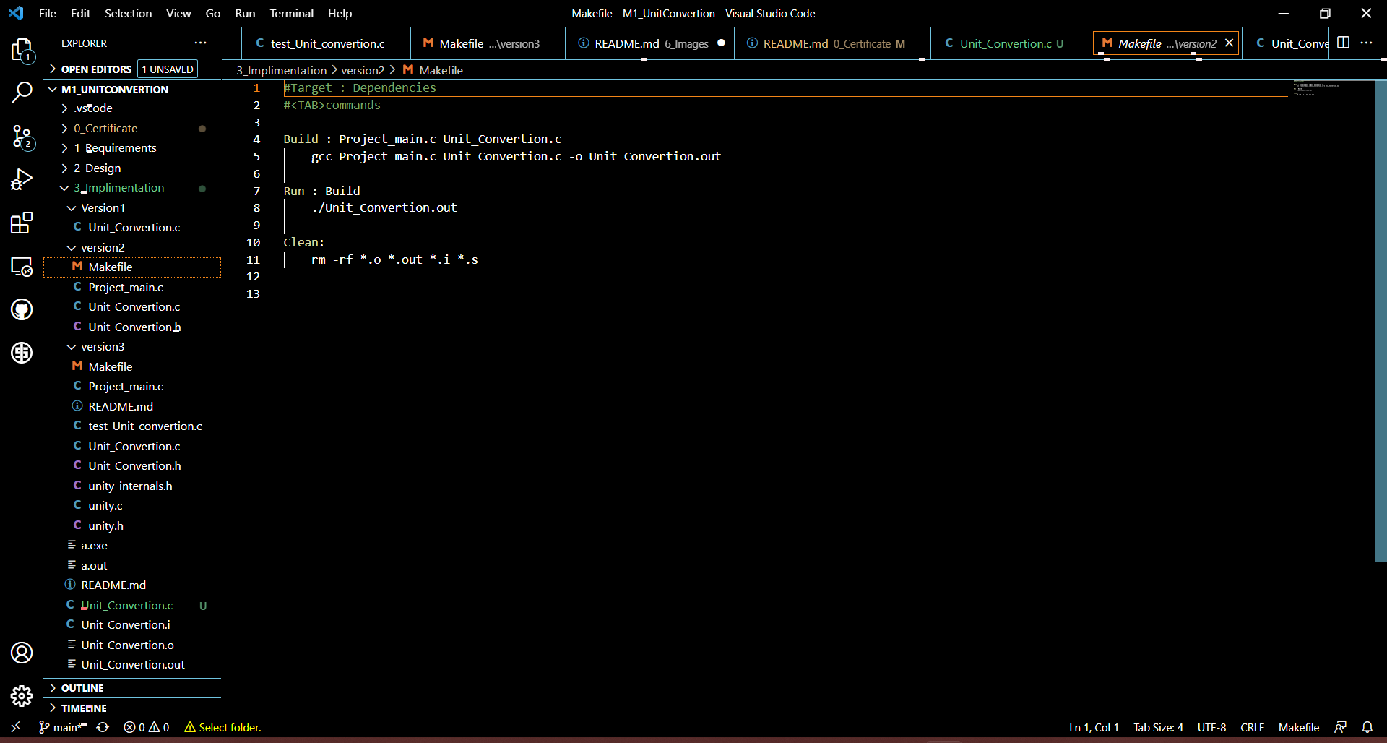

**Images: - Result, Outputs, GitHub, Running Codes and Diagram**

**Images: - Running Codes**

**Images: - GitHub**